Paper Title [Font Name: Cambria, Size:20 & Bold]
First A. Author¹ and Second B. Author² [Font Name: Cambria, Size:12]
¹Member, Institute/Organization name [Font Name: Cambria, Size:10]
²Member, Institute/Organization name [Font Name: Cambria, Size:10]
Abstract— [Font Name: Cambria, Size:10] These instructions give you guidelines for preparing papers for the Multidisciplinary International Journal of Research and Development (MIJRD). Use this document as a template if you are using Microsoft Word 6.0 or later. Otherwise, use this document as an instruction set. The electronic file of your paper will be formatted further at Multidisciplinary International Journal of Research and Development. Define all symbols used in the abstract. Do not cite references in the abstract. Do not delete the blank line immediately above the abstract.
Keywords— [Font Name: Cambria, Size:10] About four(minimum) key words or phrases in alphabetical order, separated by commas.
I. INTRODUCTION [Font Name: Cambria, Size:10]
[Font Name: Cambria, Size:10] Highlight a section that you want to designate with a certain style, then select the appropriate name on the style menu. The style will adjust your fonts and line spacing. Do not change the font sizes or line spacing to squeeze more text into a limited number of pages. Use italics for emphasis; do not underline.
To insert images in Word, position the cursor at the insertion point and either use Insert | Picture | From File or copy the image to the Windows clipboard and then Edit | Paste Special | Picture (with ―Float over text‖ unchecked) (keep text wrapping top-bottom).
Multidisciplinary International Journal of Research and Development reserves the right to do the final formatting of your paper.
II. PROCEDURE FOR PAPER SUBMISSION
A. Review Stage
Submit your manuscript electronically for review. prepare it in two-column format, including figures and tables(untill it don't fit properly and data is not visible).
B. Final Stage
After your paper has been accepted. The authors of the accepted manuscripts will be given a copyright form and the form should accompany your final submission.
C. Figures
As said, to insert images in Word, position the cursor at the insertion point and either use Insert | Picture | From File or copy the image to the Windows clipboard and then Edit | Paste Special | Picture (with ―Float over text‖ unchecked).
III. MATH
If you are using Word, use either the Microsoft Equation Editor or the Math Type add-on (http://www.mathtype.com) for equations in your paper (Insert | Object | Create New | Microsoft Equation or MathType Equation). ―Float over text‖ should not be selected.
IV. UNITS
Use either SI (MKS) or CGS as primary units. (SI units are strongly encouraged.) English units may be used as secondary units (in parentheses). This applies to papers in data storage. For example, write ―15 Gb/cm2 (100 Gb/in2). An exception is when English units are used as identifiers in trade, such as ―3½ in disk drive. Avoid combining SI and CGS units, such as current in amperes and magnetic field in oversteps. This often leads to confusion because equations do not balance dimensionally. If you must use mixed units, clearly state the units for each quantity in an equation.
The SI unit for magnetic field strength H is A/m. However, if you wish to use units of T, either refer to magnetic flux density B or magnetic field strength symbolized as μ0H. Use the center dot to separate compound units, e.g., ―A·m2.
III. HELPFUL HINTS
A. Figures and Tables
Because the final formatting of your paper is limited in scale, you need to position figures and tables at the top and bottom of each column. Large figures and tables may span both columns. Place figure captions below the figures; place table titles above the tables. If your figure has two parts, include the labels ―(a)‖ and ―(b)‖ as part of the artwork. Please verify that the figures and tables you mention in the text actually exist. Do not put borders around the outside of your figures. Use the abbreviation ―Fig.‖ even at the beginning of a sentence. Do not abbreviate ―Table. ‖ Tables are numbered with Roman numerals. Include a note with your final paper indicating that you request colour printing.
Table 1: Numerical Data of Analysis
Header 01 | Header 02 | Header 03
002 | 002 | 002
004 | 004 | 004
006 | 006 | 006
008 | 008 | 008
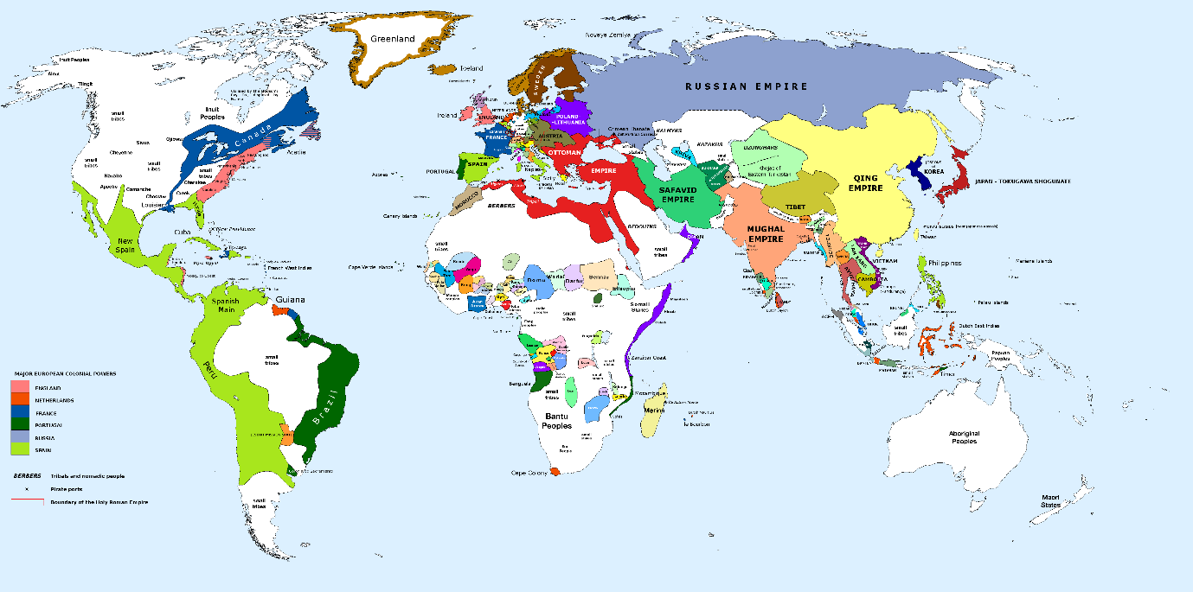
Figure 01: World Map
IV. CONCLUSION
It is a long established fact that a reader will be distracted by the readable content of a page when looking at its layout. The point of using Lorem Ipsum is that it has a more-or-less normal distribution of letters, as opposed to using 'Content here, content here', making it look like readable English. Many desktop publishing packages and web page editors now use Lorem Ipsum as their default model text, and a search for 'lorem ipsum' will uncover many web sites still in their infancy. Various versions have evolved over the years, sometimes by accident, sometimes on purpose (injected humour and the like).
APPENDIX
The appendix sits at the junction of the small intestine and large intestine. It’s a thin tube about four inches long. Normally, the appendix sits in the lower right abdomen.
The function of the appendix is unknown. One theory is that the appendix acts as a storehouse for good bacteria, “rebooting” the digestive system after diarrheal illnesses. Other experts believe the appendix is just a useless remnant from our evolutionary past. Surgical removal of the appendix causes no observable health problems.
ACKNOWLEDGMENT
Acknowledgement letter is very short business letter, and is intended to communicate brief and clear message. It is quite common to use this letter if you are not aware at the time of future developments in regard to someone’s query. It is quite common to use this letter if you are not aware at the time of future developments in regard to someone’s query. It is quite common to use this letter if you are not aware at the time of future developments in regard to someone’s query.
REFERENCES
- G. Eason, B. Noble, and I. N. Sneddon, “On certain integrals of Lipschitz-Hankel type involving products of Bessel functions,” Phil. Trans. Roy. Soc. London, vol. A247, pp. 529–551, April 1955. PDF: https://www.exapmple.com/file/download.pdf.
- J. Clerk Maxwell, A Treatise on Electricity and Magnetism, 3rd ed., vol. 2. Oxford: Clarendon, 1892, pp.68–73. DOI: http://dx.doi.org/10.1453/mijrd/v1234.
- S. Jacobs and C. P. Bean, “Fine particles, thin films and exchange anisotropy,” in Magnetism, vol. III, G. T. Rado and H. Suhl, Eds. New York: Academic, 1963, pp. 271–350. URL: https://www.website.com/example.html.
- K. Elissa, “Title of paper if known,” unpublished. File: https://file.dowload.com/dir/file.docx.
- R. Nicole, “Title of paper with only first word capitalized,” J. Name Stand. Abbrev., in press.
- Y. Yorozu, M. Hirano, K. Oka, and Y. Tagawa, “Electron spectroscopy studies on magneto-optical media and plastic substrate interface,” IEEE Transl. J. Magn. Japan, vol. 2, pp. 740–741, August 1987 [Digests 9th Annual Conf. Magnetics Japan, p. 301, 1982].
- M. Young, The Technical Writer’s Handbook. Mill Valley, CA: University Science, 1989.

